Welcome to Uasin Gishu county: Mutithi Ward

KAPTAGAT WARD
Connect with Maize farmers

Ainabkoi Sub county Contact a Farmer in Kaptagat ward and order your Maize
 | PHOTO | Name / Contact | BUSINESS NAME | Type of Maize | Price per kg | AIR TEL / MPESA  Bank
1 | 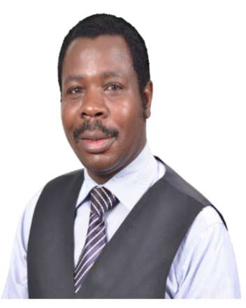 | Daniel Abukuse  Contact  0739688217 | Tree Foods Systems | Dry Maize |  | 0723238416
 |  |  |  | Green maize |  | PAYBIL 247247
 |  |  |  | GMO maize |  | ACCOUNT
 |  |  |  | Yellow maize |  | 0723238416
 |  |  |  |  | Price per kg
2 |  | Daniel Abukuse  Contact  0739688217 |  | Dry Maize
 |  |  |  | Green maize |  | PAYBILL
 |  |  |  | GMO maize
 |  |  |  | Yellow maize |  | ACCOUNT
 |  |  |  |  | Price per kg
3 |  | Daniel Abukuse  Contact  0739688217 |  | Dry Maize
 |  |  |  | Green maize |  | PAYBILL
 |  |  |  | GMO maize
 |  |  |  | Yellow maize |  | ACCOUNT
 |  |  |  | Dry Maize
 |  |  |  |  | Price per kg
4 |  | Daniel Abukuse  Contact  0739688217 |  | Dry Maize
 |  |  |  | Green maize |  | PAYBILL
 |  |  |  | GMO maize
 |  |  |  | Yellow maize |  | ACCOUNT
 |  |  |  | others
 |  |  |  |  | Price per kg
5 |  | Daniel Abukuse  Contact  0739688217 |  | Dry Maize
 |  |  |  | Green maize |  | PAYBILL
 |  |  |  | GMO maize
 |  |  |  | Yellow maize |  | ACCOUNT
 |  |  |  | others
 |  |  |  |  | Price per kg
6 |  | Daniel Abukuse  Contact  0739688217 |  | Dry Maize
 |  |  |  | Green maize |  | PAYBILL
 |  |  |  | GMO maize
 |  |  |  | Yellow maize |  | ACCOUNT
 |  |  |  | others
6 |  |  |  |  | Price per kg
7 |  | Daniel Abukuse  Contact  0739688217 |  | Dry Maize |  | PAYBILL
 |  |  |  | Green maize
 |  |  |  | GMO maize |  | ACCOUNT
 |  |  |  | Yellow maize
 |  |  |  | others
 |  |  |  |  | Price per kg
8 |  | Daniel Abukuse  Contact  0739688217 |  | Dry Maize |  | PAYBILL
 |  |  |  | Green maize
 |  |  |  | GMO maize |  | ACCOUNT
 |  |  |  | Yellow maize
 |  |  |  | others
 |  |  |  |  | Price per kg
9 |  | Daniel Abukuse  Contact  0739688217 |  | Dry Maize
 |  |  |  | Green maize |  | PAYBILL
 |  |  |  | GMO maize
 |  |  |  | Yellow maize |  | ACCOUNT
 |  |  |  | others

