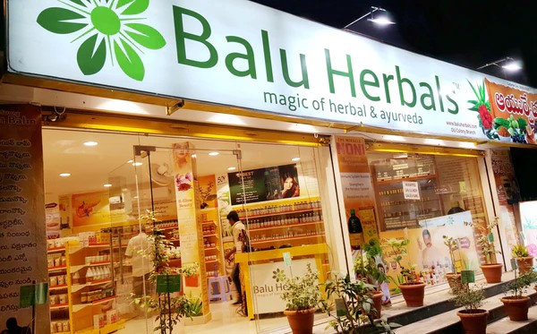

Replace in red to suit your information, produce a photo of your business

s

|  |  |  |
| --- | --- | --- |
| Herbal Name shop | Location | Contact |
| Balu Herbals company  P.o. Box…………. | Street | 0739688XXX  Email:balu@gmail.com  Order / we can send as a parcel  www.baluberbals.org  see our catalog |
| Nairobi / Mfangano |
| Shop building name |
| Balu house | County: |
| Nairobi |
| Shop number | Sub county: |
| 654 | Nairobi central |
| Pay bill  Account |

Email : [kenyatreefoodsystems@gmail.com](mailto:kenyatreefoodsystems@gmail.com)

On subject : Herbal