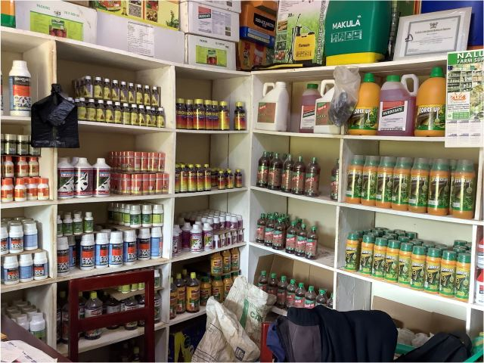

Replace in red to suit your information, produce a photo of your business

|  |  |  |
| --- | --- | --- |
| Agrovet Name | Location | Contact |
| Jasma Agrovet company  P.o. box | Street | 0739688XXX  Email:jasm@gmail.com  Order / we can send as a parcel  www. Jasmaagrovet.org  see our catalog |
| Nairobi / Mfangano |
| Shop building Name | County: |
| Jasma house | Nairobi |
| Shop Number | Sub county: |
| 354 | Nairobi central |
| Pay bill  Account |

Email : [kenyatreefoodsystems@gmail.com](mailto:kenyatreefoodsystems@gmail.com)

On subject : Agrovet